DATE: 14.02.2020
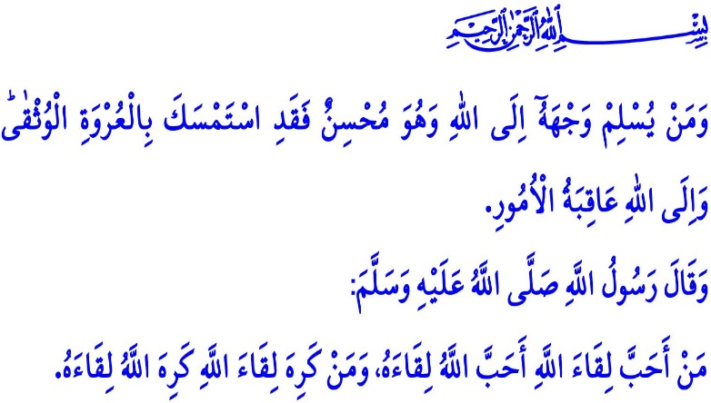
THE BOND BETWEEN ALLAH AND HIS SERVANTS
Honorable Muslims!
In the verse I have recited, Allah (swt) states, "And whoever submits his face to Allah while he is a doer of good - then he has grasped the most trustworthy handhold. And to Allah will be the outcome of all matters."
In the hadith I have recited, Prophet Muhammad says, "Whoever wants to meet Allah, Allah wants to meet him, too. Whoever does not want to meet Allah, Allah does not want to meet him, either."
Dear Believers!
Allah the Almighty is the only reason for our existence. Upon His command "Be!", all creations between heavens and earth find their place in the world. It is Allah, Who creates us from nothing, makes us live through His might, bounty and help, and puts us to a test through His blessings.
We are responsible against Allah, from the moment we wake up in the morning till we go to sleep at night, in every breath and every step we take, and in every decision we make. Prophet Muhammad (saw) refers to this responsibility in one occasion, "The right of Allah over His slaves is that they should worship Him and not associate anything with Him." Then they show they believe in tawhid and build their lives based on it. Then Allah promises them, "He shall not punish them, and He shall put them in paradise."
Dear Muslims!
When the servants of Allah have sincere faith in Him, He becomes pleased with them. Having sincere faith requires wholeheartedly worshipping and living in accordance with good morals. Muslims show their love, respect, and obedience to Allah not only through worships but also their moral behaviors.
Allah responds to the prayers and supplications of His believing servants. He (swt) does not leave those, who try to obtain His consent, alone and unaided. Whenever His servants ask, "When is the help of Allah?", He (swt) welcomes their question with, "Unquestionably, the help of Allah is near." In a hadith qudsi, Prophet Muhammmad (saw) says, "I am just as My servant thinks I am, (i.e. I am able to do for him what he thinks I can do for him) and I am with him if He remembers Me. If he remembers Me in himself, I too, remember him in Myself; and if he remembers Me in a group of people, I remember him in a group that is better than them. If he comes one span nearer to Me, I go one cubit nearer to him; and if he comes one cubit nearer to Me, I go a distance of two outstretched arms nearer to him; and if he comes to Me walking, I go to him running."
Dear Believers!
People can sometimes be ungrateful and egoistic, and pushy and careless. We are merely servants. Sometimes we happen to forget that Allah sees, hears, and expects good deeds from us at all times. We find ourselves committing sins, and making mistakes, knowingly or forgetfully. We happen to do things we would greatly regret when the dark clouds set down on our way, when our foot slips, and when our eyes are closed.
No matter what, our only shelter is Allah, Who is the Most Merciful of all the Merciful. Allah is forgiving and loves to forgive. He (swt) keeps open the door of mercy and forgiveness until our last breath. It is stated in the Holy Qur'an, "O My servants who have transgressed against themselves [by sinning], do not despair of the mercy of Allah. Indeed, Allah forgives all sins. Indeed, it is He who is the Forgiving, the Merciful."
Dear Muslims!
Allah warns us in the Qur'an, "And be not like those who forgot Allah, so He made them forget themselves." Let us heed this warning. Let us properly protect and strengthen the bond of servitude between Allah and us. Let us duly worship Him and let us ask for help from Him (swt) only. Let us wholeheartedly pray to Him. Let us repent for all our sins. Let us not forget that if we forget Allah and lose our bond with Allah, then He pushes us away from His mercy. He (swt) instills fear in hearts in the world, and He does not care about us and puts us in a great punishment in the Hereafter.

Luqman, 31/22.
Bukhari, Riqaq, 41; Muslim, Dhikr, 14.
Muslim, Iman, 48; Bukhari, Jihad, 46.
Baqarah, 2/214.
Bukhari, Tawhid, 15.
Zumar 39/53.
Hashr, 59/19. General Directorate of Religious Services

